**Name : Salma Rani**

**Sap Id : 54194(BSCS-4).**

**Lab: Web App Development.**

**Submitted To: Mam Nayab.**

**Login:**

<!DOCTYPE html>

<html>

<head>

    <link rel="stylesheet"href ="style.css">

    <meta charset="UTF-8" />

    <title>login page</title>

</head>

<body>

    <div class="main"

<form>

<h3>LOGIN FORM</h3>

<label>Email:</label>

<br>

<input type="text" placeholder="username" required>

<br>

<label>Password:</label>

<br>

<input type="password" placeholder="Enter your password" required>

</form>

<p> Don't have an account <a href="signup.html">Sign-up Here</a></p>

<button>login</button>

</div>

</body>

</html>

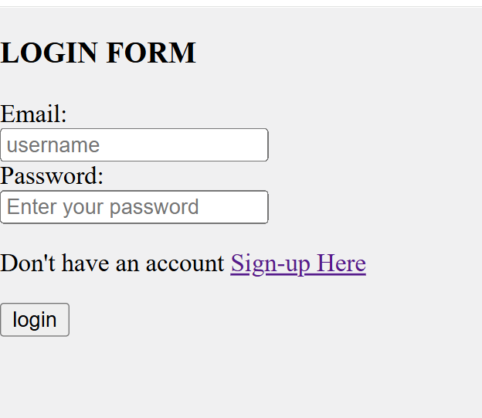

**Signup:**

<!DOCTYPE html>

<html>

<head>

    <link rel="stylesheet"href ="style.css">

    <meta charset="UTF-8" />

    <title>login page</title>

</head>

<body>

    <div class="main"

<h3>REGISTRATION FORM</h3>

<form>

    <label>Username:</label>

    <br>

    <input type="text" name="username" required>

    <br>

    <label>Email:</label>

    <br>

    <input type="email" name="email" required>

    <br>

    <label>Password:</label>

    <br>

    <input type="password" name="password" required>

    <br>

    <label>Confirm Password:</label>

    <br>

    <input type="password" name="confirm_password" required>

    <br>

    <button type="submit">Register</button>

    <p> Already have an account <a href="login.html">Login Here</a></p>

</form>

<button>login</button>

</div>

</body>

</html>

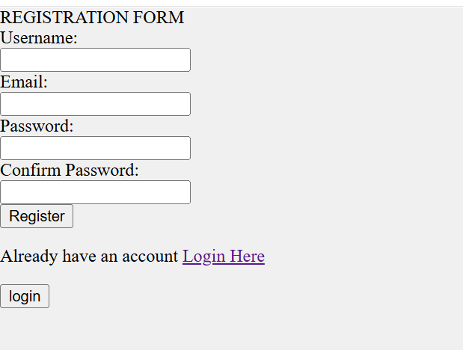

**Style.css:**

body{

font-family: 'Times New Roman', Times, serif;

background-color: rgb(240, 240, 241);

margin: 0;

padding: 0;

}

.navbar{

    background-color: rgba(219, 201, 40, 0.79);

    overflow: hidden;

    display:flex;

    justify-content: space-between;

    align-items: center;

    padding: 10px 20px;

}

.navbar.logo{

    color: rgb(0, 0, 0);

    font-size:24px;

    font-weight: bold;

}

**Index.Html:**

<!DOCTYPE html>

<html lang="en">

<head>

    <link rel="stylesheet" href="style.css">

    <meta charset="UTF-8">

    <meta name="viewport" content="width=device-width, initial-scale=1.0">

    <title>MyWebsite</title>

    <style>

        .slider {

            width: 100%;

            max-width: 800px;

            height: 400px;

            overflow: hidden;

            position: relative;

            margin: auto;

        }

        .slides {

            display: flex;

            width: 500%;

            transition: transform 0.5s ease-in-out;

        }

        .slides img {

            width: 100%;

            height: auto;

        }

        .prev, .next {

            position: absolute;

            top: 50%;

            transform: translateY(-50%);

            background-color: rgba(0, 0, 0, 0.5);

            color: white;

            border: none;

            padding: 10px;

            cursor: pointer;

        }

        .prev { left: 10px; }

        .next { right: 10px; }

    </style>

</head>

<body>

    <nav class="navbar">

        <div class="logo">MyWebsite</div>

        <ul class="nav-links">

            <li><a href="#">Home</a></li>

            <li><a href="#">Services</a></li>

            <li><a href="#">Contact</a></li>

            <li><a href="login.html">Sign In</a></li>

            <li><a href="signup.html">Sign Up</a></li>

        </ul>

    </nav>

    <div class="slider">

        <div class="slides">

            <img src="images.html/image2.jpg" alt="slide 2">

            <img src="images.html/image4.jpg" alt="slide 3">

            <img src="C:\Users\INFOTECH\OneDrive\Desktop\web app development\images.html\image3.jpg" alt="slide 4">

            <img src="C:\Users\INFOTECH\OneDrive\Desktop\web app development\images.html\image3.jpg" alt="slide 5">

            <img src="images.html/image2.jpg" alt="slide 3">

        </div>

        <button class="prev" onclick="prevSlide()">&#10094;</button>

        <button class="next" onclick="nextSlide()">&#10095;</button>

    </div>

    <script>

        let index = 0;

        function showSlide(n) {

            let slides = document.querySelector('.slides');

            let totalSlides = document.querySelectorAll('.slides img').length;

            if (n >= totalSlides) index = 0;

            if (n < 0) index = totalSlides - 1;

            slides.style.transform = `translateX(${-index * 100}%)`;

        }

        function nextSlide() {

            index++;

            showSlide(index);

        }

        function prevSlide() {

            index--;

            showSlide(index);

        }

        setInterval(nextSlide, 3000); // Auto-slide every 3 seconds

    </script>

</body>

</html>

<img src="images.html/image2.jpg" alt="slide 2">

                                <img src="images.html/image4.jpg" alt="slide 3">

                                <img src="C:\Users\INFOTECH\OneDrive\Desktop\web app development\images.html\image3.jpg" alt="slide 4">

                                <img src="C:\Users\INFOTECH\OneDrive\Desktop\web app development\images.html\image3.jpg" alt="slide 5">

                                <img src="images.html/image2.jpg" alt="slide 3">

